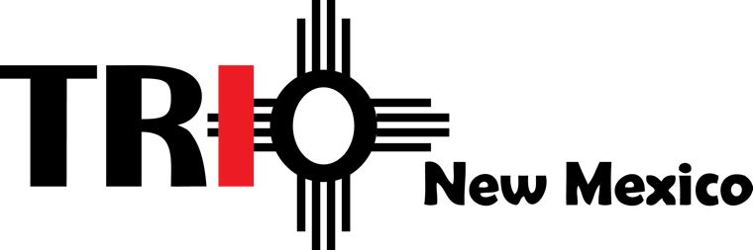

TRIO Day 2021 Agenda

Friday, February 26th, 1:00 – 4:45 pm
Zoom event

1:00-1:25 Welcome Activity
- TRIO alumni stories

1:30-3:00 Student and Staff Leadership Workshops Presented by Paradigm Shift
- Pre-college students
  - Growth Mindset vs. Fixed Mindset
- College students
  - Change Management: Adapting for Success
- Staff
  - Change Management: Adapting for Success

3:00-3:30 Break

3:30-4:00 New Mexico Legislative Comments and Support

4:00-4:45 Student Testimonials and Group Picture

Change Management: Adapting for Success
Change has always been a necessary aspect of life and work, and our world
is changing more rapidly than ever. Your students will need to cope with a
variety of changes in the near future, and their success and professional
and personal fulfillment depend on how well they can adapt to change.
This workshop goes through the cycles of change and how to tackle it
head-on.

Growth Mindset vs. Fixed Mindset
To optimize our potential, we must grow! Growing at times means that we need
to try something new or change! Both can be challenging! Both can be
uncomfortable, but they are necessary! In this workshop, we learn that growing
in mindset renders much more reward then staying in a fixed mindset.

Registration is $65 per participant and covers the cost for guest speakers, TRIO Day t-shirts, virtual platform and banking fees.

- TRIO programs register via the TRIO New Mexico website (https://www.trionewmexico.com/).
- Programs must also submit the TRIO Day Registration Details Excel Form to TRIO Day Committee Chair Katie Bryant (kmbryant@unm.edu). The form is found on the registration website.

Resource Guide for Virtual Activities (college tours, museum tours, etc.)

