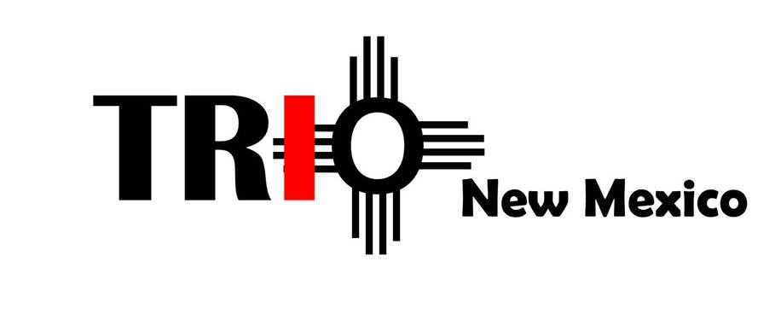

PROXY FORM

I ________________________________ OF ___________________________

*(PLEASE PRINT NAME)*

*(PLEASE PRINT INSTITUTION NAME)*

BEING AN **ACTIVE MEMBER** WITH VOTING RIGHTS OF TRIO NEW MEXICO, HEREBY AUTHORIZE:

________________________________ OF ___________________________

*(PLEASE PRINT NAME)*

*(PLEASE PRINT INSTITUTION NAME)*

BEING AN **ACTIVE MEMBER** WITH VOTING RIGHTS OF TRIO NEW MEXICO TO VOTE ON MY BEHALF AS MY PROXY AT THE SPRING BUSINESS MEETING FOR THE ASSOCIATION, TO BE HELD ON FRIDAY, APRIL 12, 2019.

SIGNATURE: _____________________________ DATE:______________________

**PLEASE NOTE:**

PER SECTION 6.2 OF THE TRIO NEW MEXICO BYLAWS, THE TRIO NEW MEXICO PRESIDENT MUST RECEIVE ALL PROXY FORMS PRIOR TO THE COMMENCEMENT OF THE TRIO NEW MEXICO BUSINESS MEETING; FORMS WILL THEN BE SUBMITTED TO THE TRIO NEW MEXICO SECRETARY TO BE KEPT ON FILE.